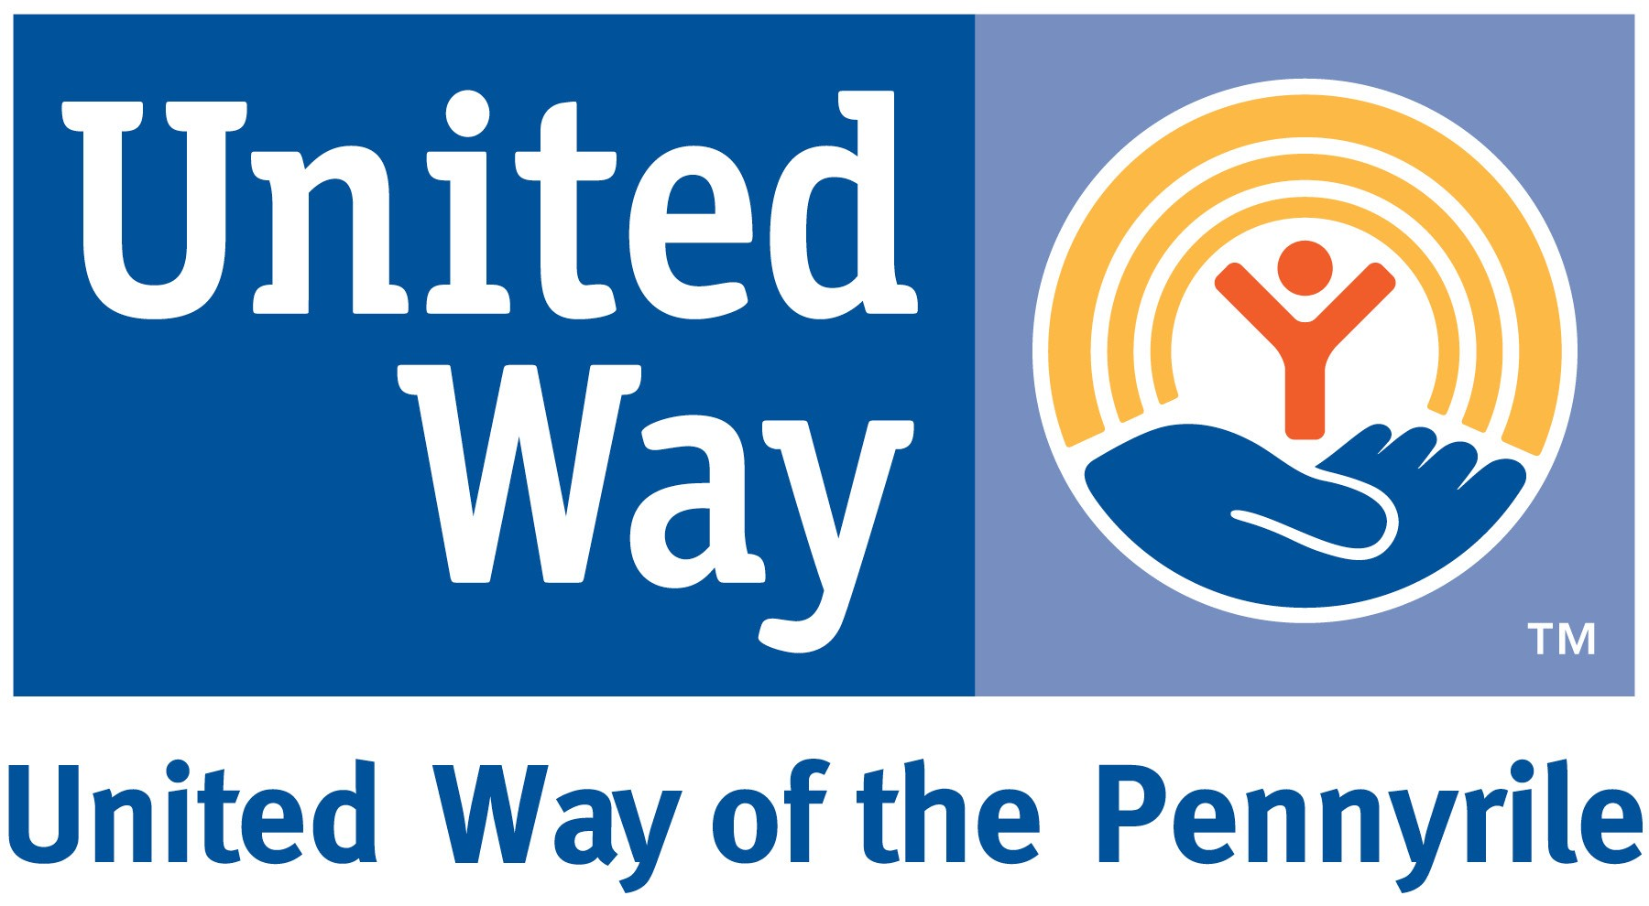

Talking Points for Worksite Campaigns

Benefits for your company:
* Builds employee morale and fosters a sense of team spirit
* Cultivates leaders through employee development opportunities
* Provides information on critical community issues and opportunities to be a part of the solution
* Connects your company and employees to the community
Benefits for individuals:
* Helps employees make informed investments
* Helps employees become involved with local non-profit agencies
* Provides information on local health and human service needs

Why Partner with United Way?
To maximize impact
* Brings together individuals, businesses, nonprofits, and agencies
* Collaborates on targeted community solutions
To drive positive community change
* Addresses root causes of problems, not just symptoms
* Invests in proven solutions and supports innovative ideas
* Measures results and reports back to you
To reach the whole community
* Offers a centralized, community-wide fundraising approach
* Provides cost-effective and efficient services
* Supports local nonprofit health and human service agencies
* Provides volunteer opportunities through our partner agencies and our panel review process

Quick Tips for a Worksite Campaign
- Recruit a Worksite Campaign Coordinator and Committee
- Determine a 2 – 3 week time period for the campaign.
- Get ideas and materials from United Way
- Schedule and announce a presentation by United Way and agency staff – preferably in conjunction with a staff meeting, to ensure good attendance. Offer refreshments.
- Set a worksite goal and keep employees posted on your progress.
- Offer payroll deduction option.
- Secure Company match for employee donations where appropriate.
- Distribute pledge forms and brochures to all employees via paychecks, employee mailboxes, or preferably at a meeting. Include memo from Campaign Coordinator and/or CEO encouraging participation.
- Offer incentives for early pledges, first time donors, prize drawings for all donations, etc.
- Hold friendly competitions between departments.
- Hold friendly competitions between similar workplaces.
- Hold special events to raise additional funds from those not interested in payroll deductions – car washes, pie contests, bake sales, can drives, etc.
- Remind employees a week before deadline and at deadline.
- Collect pledge forms, checks, and cash. Send with report form to United Way.
- Thank everyone who participated.
- Celebrate!
United Way Opposes Coercion
United Way of the Pennyrile believes that the most responsive contributors are those who are informed and involved. A well-planned campaign with an effective communications program that is run by committed volunteers will ensure responsible contributors. Fundraising should always be conducted in a voluntary manner, without pressure. Giving is a personal decision and coercion is unacceptable to United Way.

